Assignment (1.1 RSync)

On a linux server setup a cron job for copying example data with rsync periodically.
Ensure the copying is handled in the background and independently of the user session.

Solution

To setup a cron jon we have to edit the system wide crontab file by using command sudo crontab -e.

Rsync – is a utility which is use for the synchronization of files and folder.
And we have to install rsync by sudo atp-get install rsync command.

Cron job is also work in background.

Above command will open crontab file and then we will add the command in it.

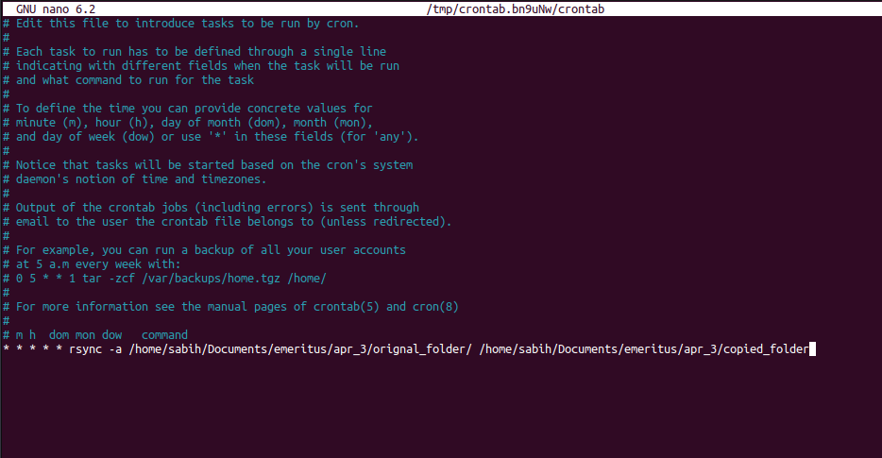

* * * * * rsync -a /home/sabih/Documents/emeritus/apr_3/orignal_folder/ /home/sabih/Documents/emeritus/apr_3/copied_folder

In the above command:

- * * * * *: shows the repetition of command execution which is every minute, every hour, every day, every month, every day.
- Rsync -a: is a normal option to synchronize the file.
- Than we have source path.
- Than we have destination path.

orignal_folder:

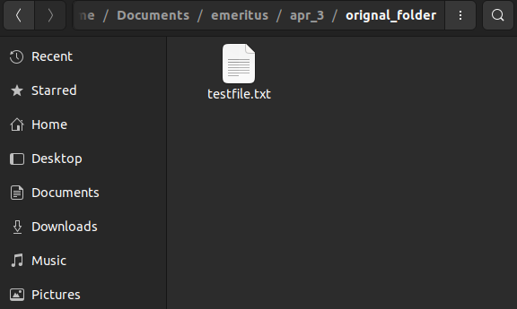

copied_folder:

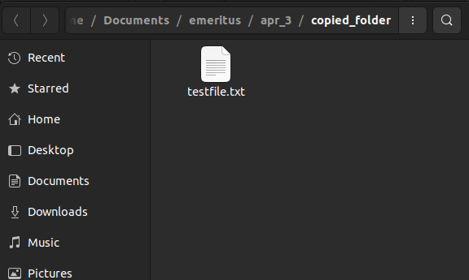

Conclusion:

The command
“* * * * * rsync -a /home/sabih/Documents/emeritus/apr_3/orignal_folder/ /home/sabih/Documents/emeritus/apr_3/copied_folder” in sudo will run independently of the user session and in the background and copy the changes of file in the destination folder.

